## Bugs Founded: 4

TS: Trying to make a purchase with no products in the cart

Since I don't have any products in my shopping cart

Scenario:

GIVEN I didn't select any product

AND I went to the carts tab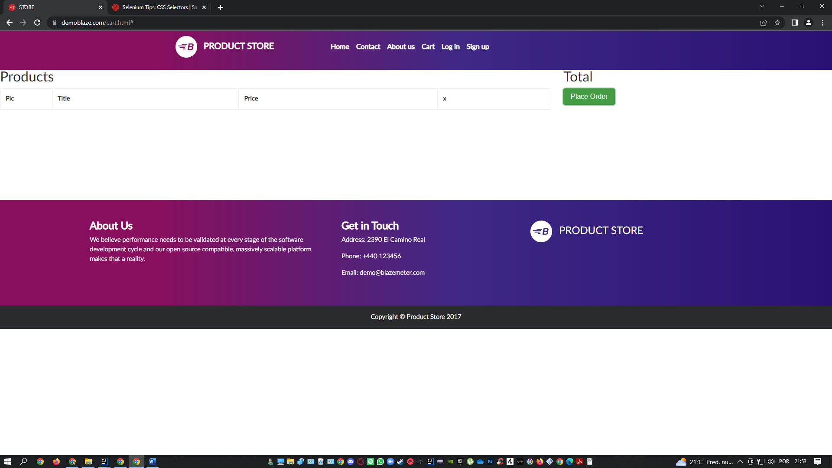

WHEN I click on the “place order” button: 

THEN the application allows me to add the data and make the purchase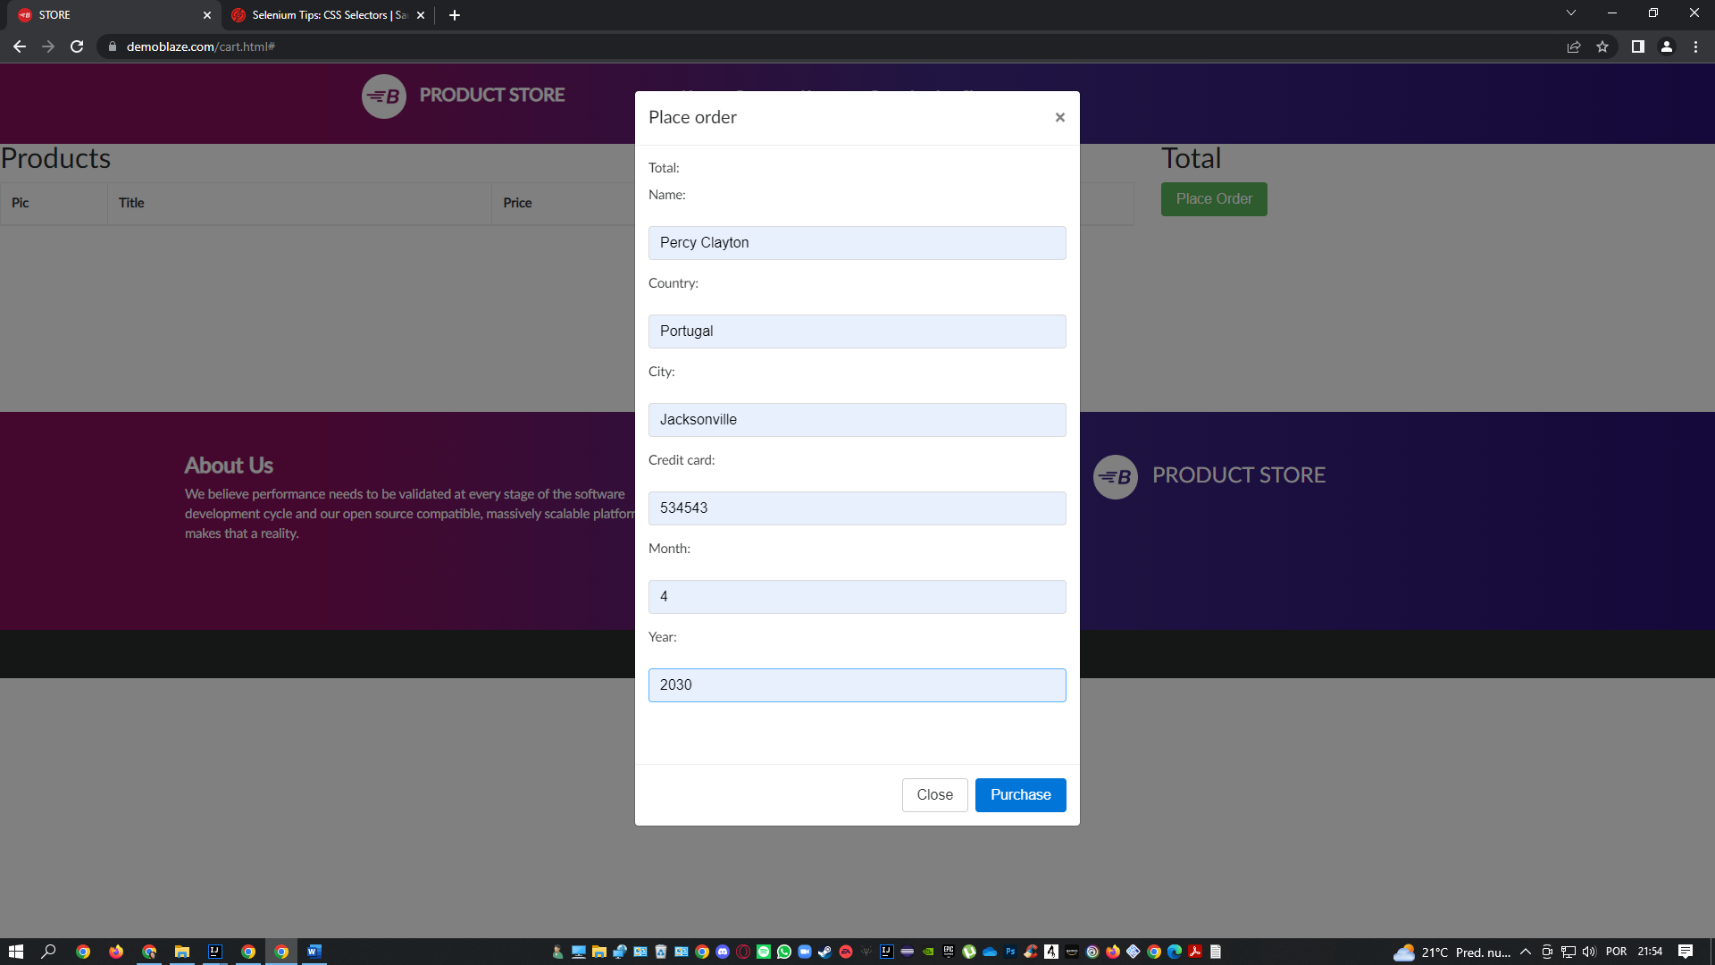

THEN a $0 order number is generated:

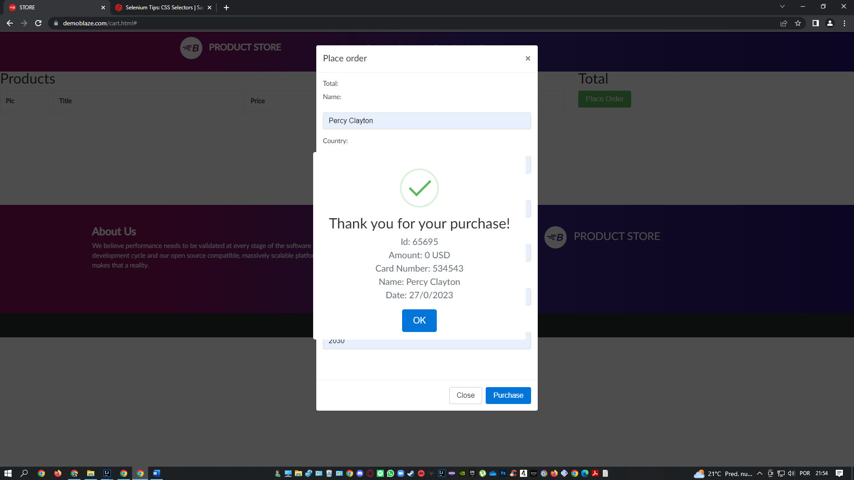

TS – In the registration step, none of the fields have special character validation, invalid type or accents validations

GIVEN I selected a product

AND proceeded to the payment step

WHEN I add the incorrect registration data:

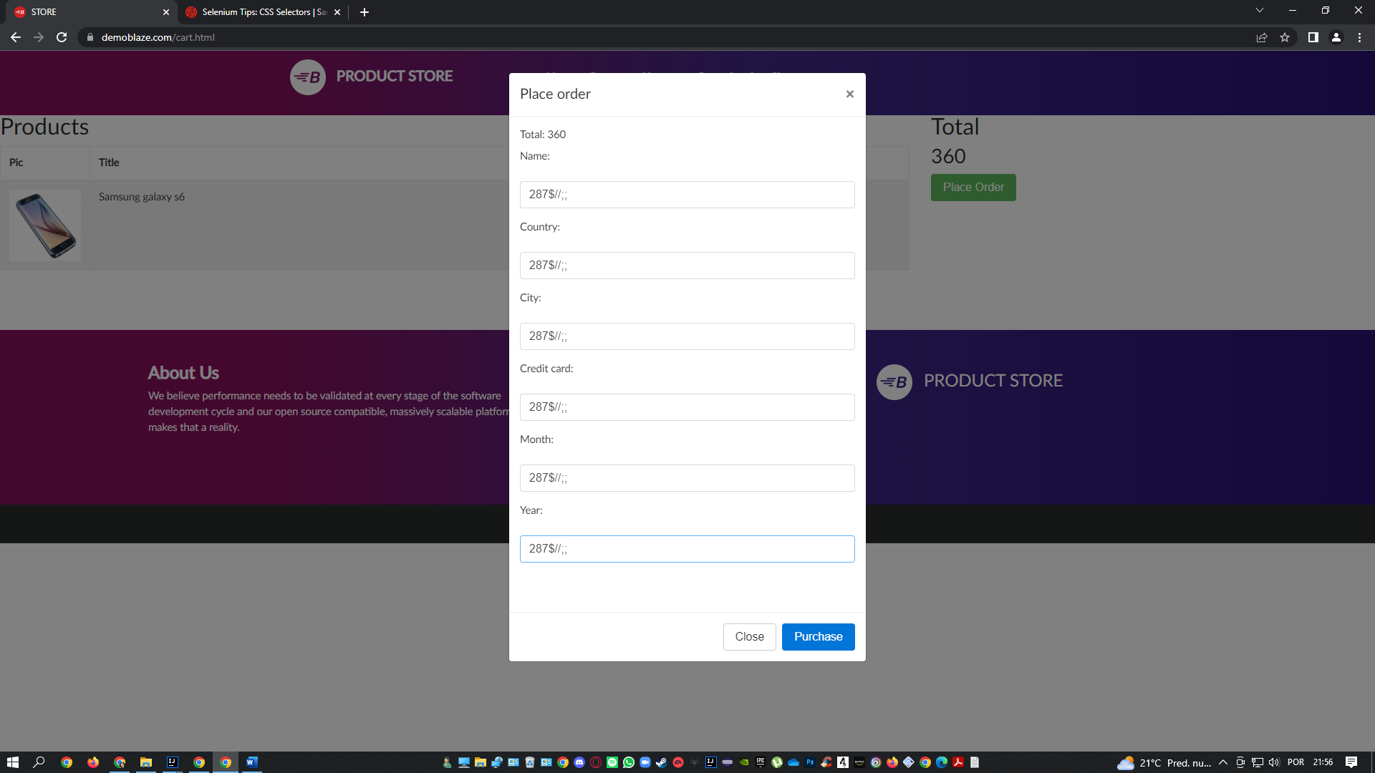

THEN the application allows me to finalize the purchase with incorrect data filled in

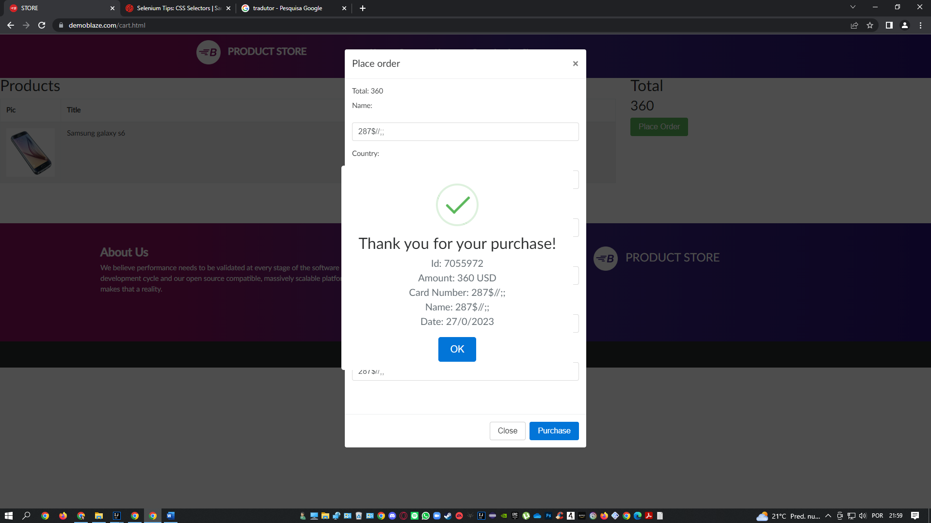

TS: It is allowed to carry out the registration step without filling in the address data

WHEN I am in the payment step

AND I Don’t write my address information’s

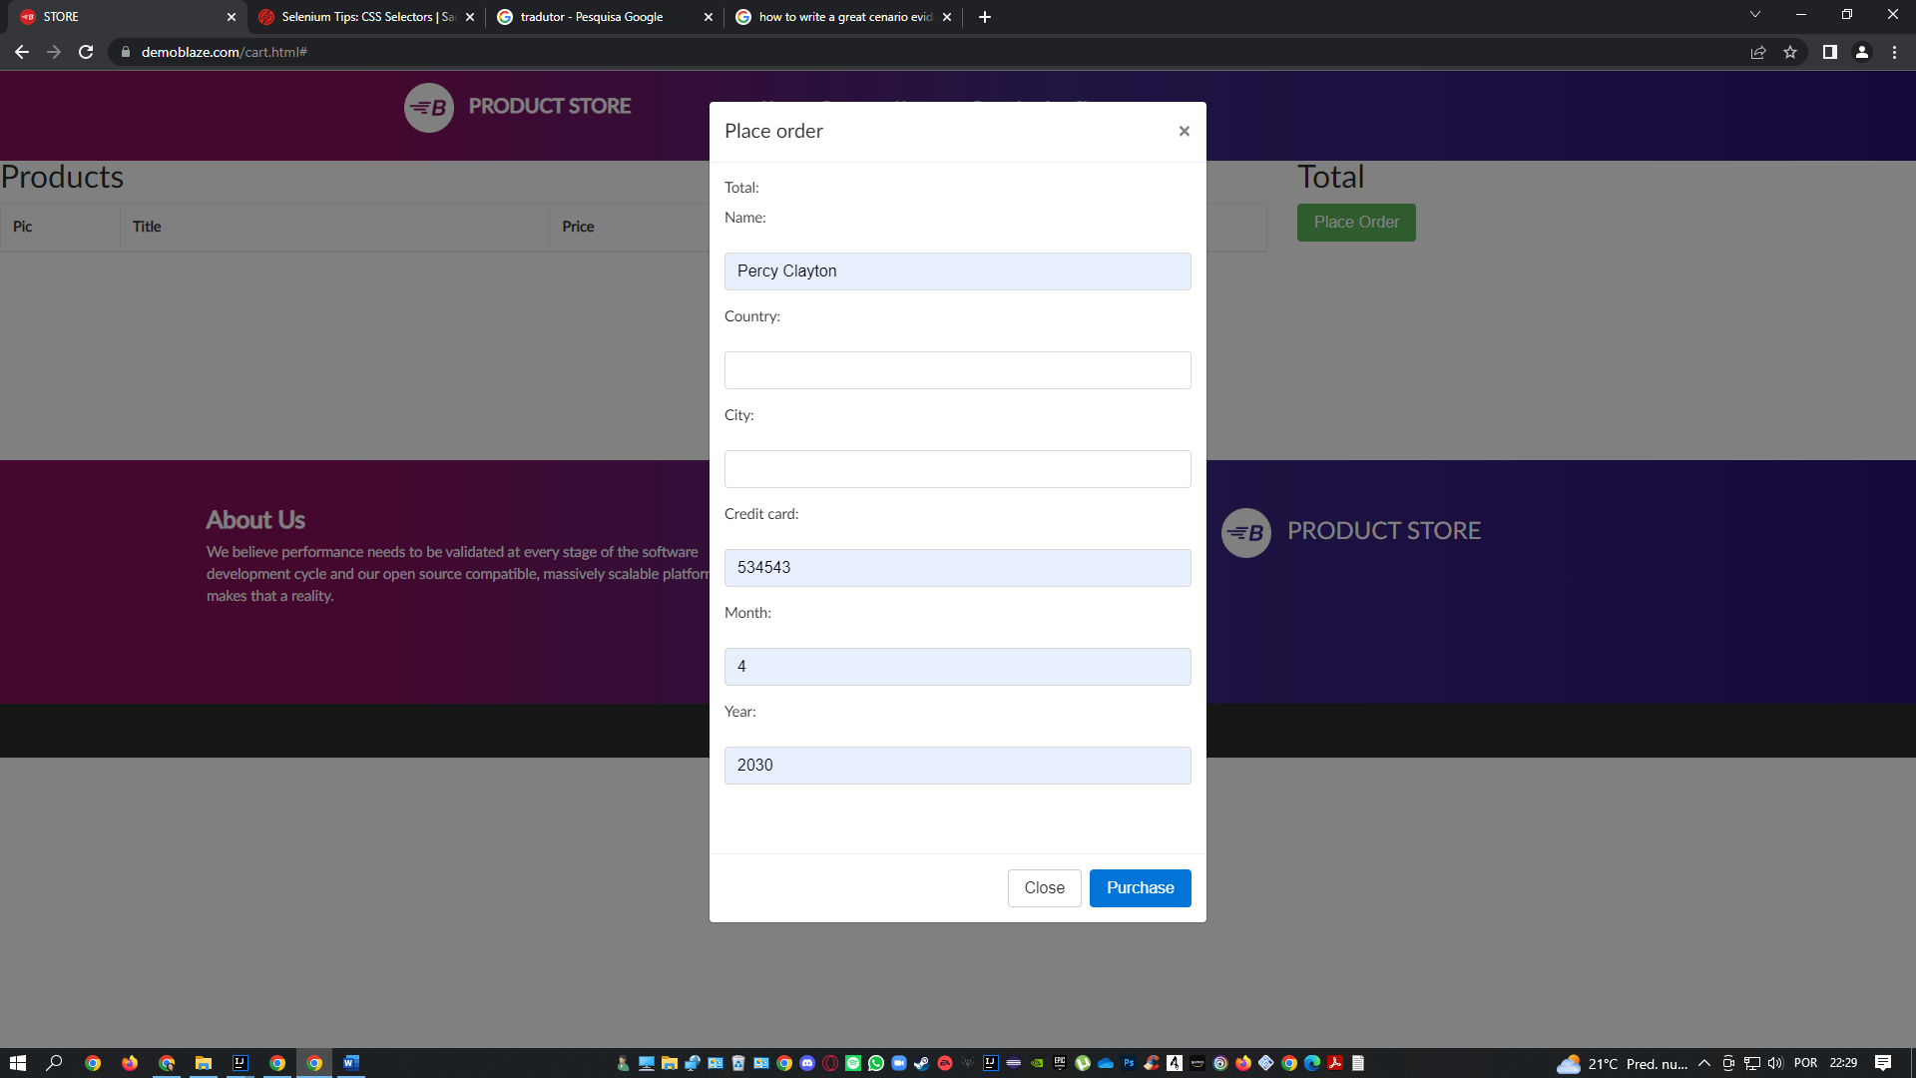

THEN it is allowed to make the purchase

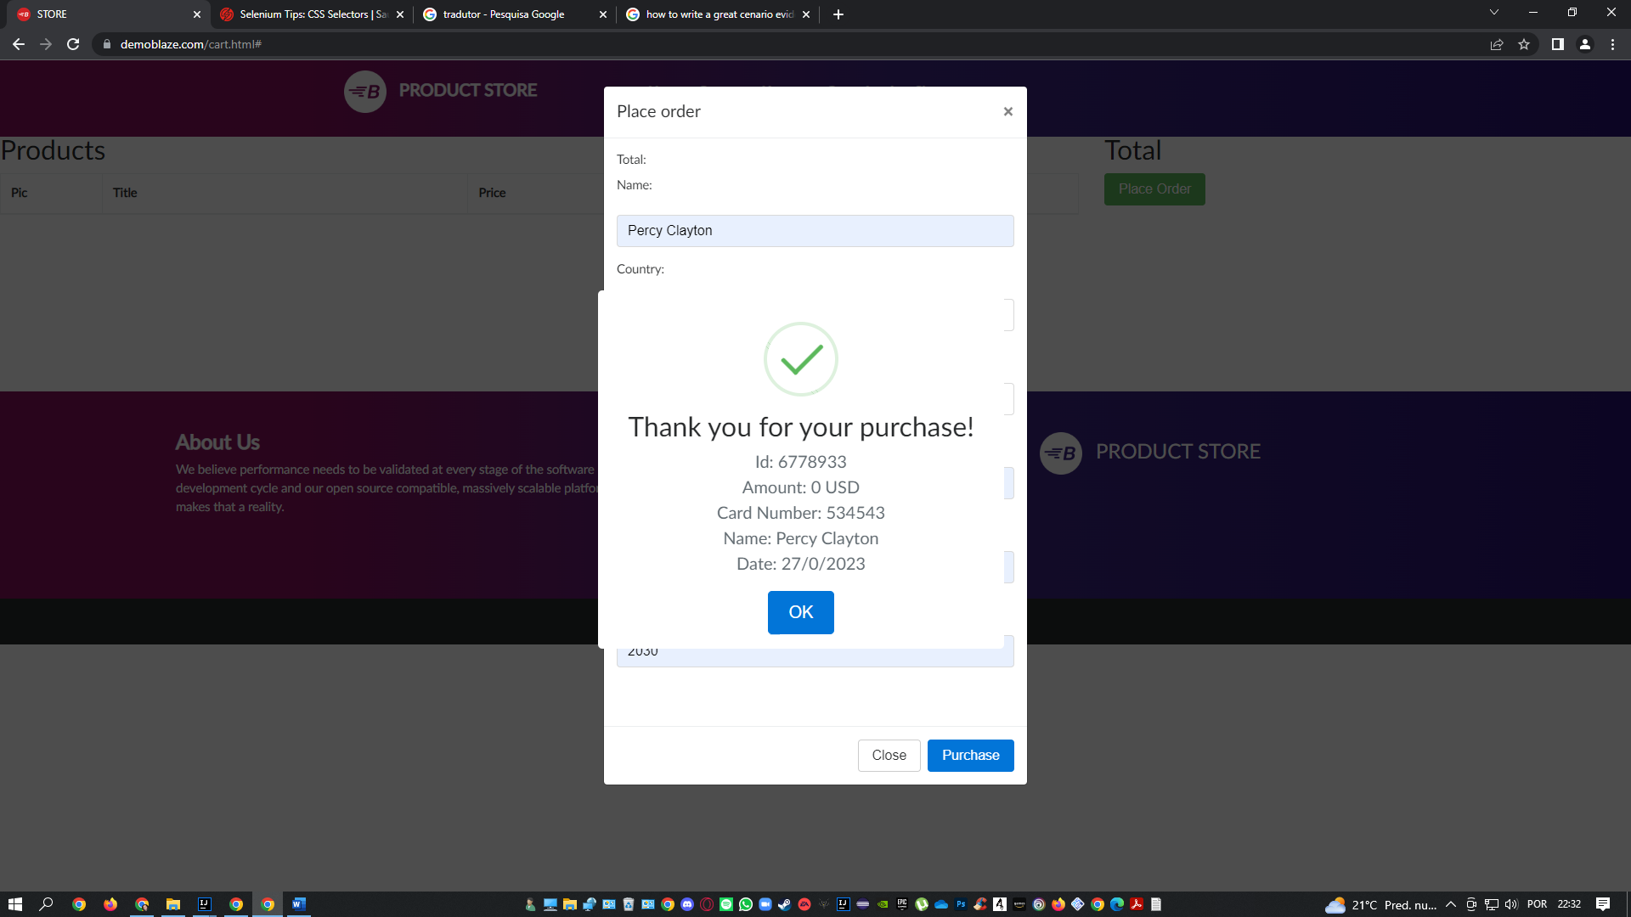

TS: In the “About us” section, the play icon is founded in upper left corner, instead of center

WHEN I go to about us section

THEN the play icon is founded in upper left corner, instead of center

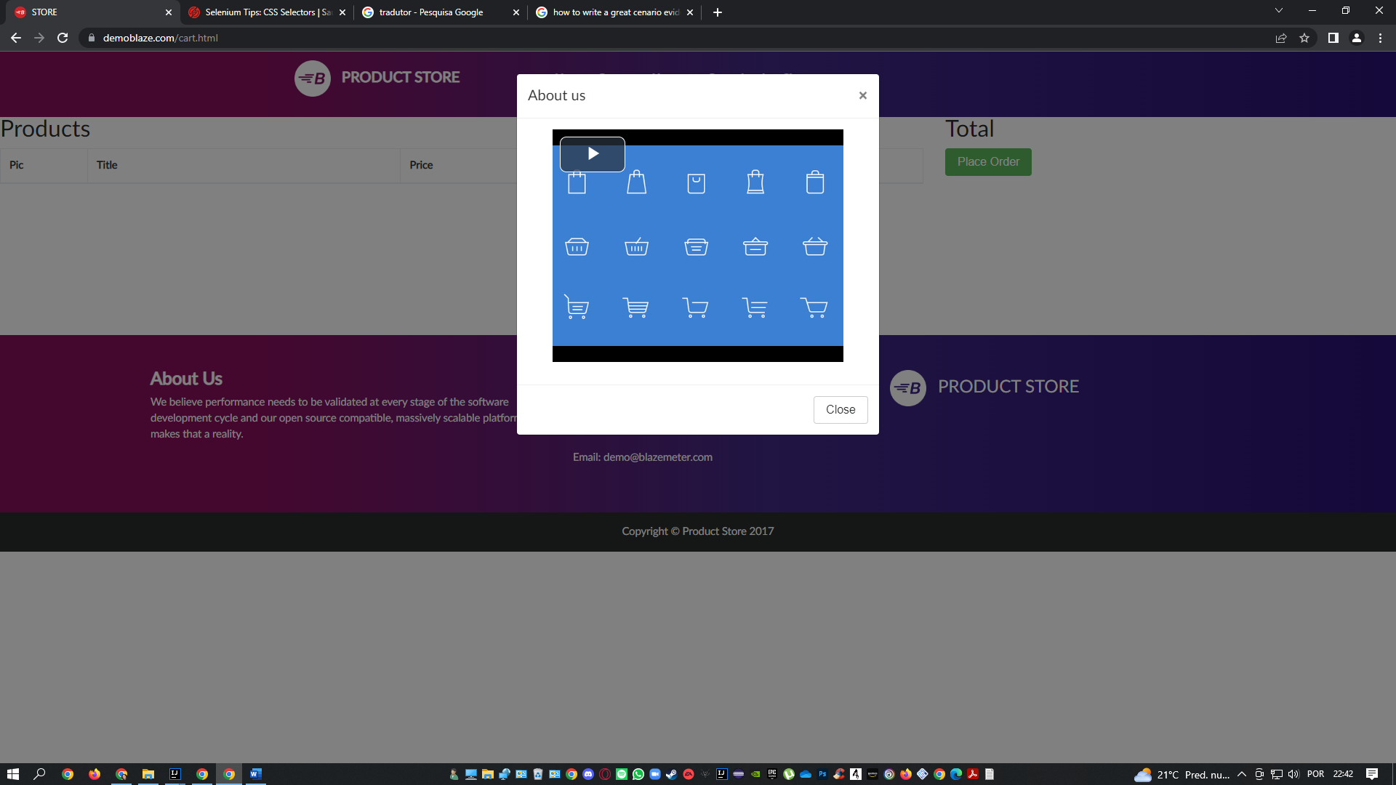

## Recomendations: 2

1. The location of the footer on the details page of the selected products is not the last item in the page structure: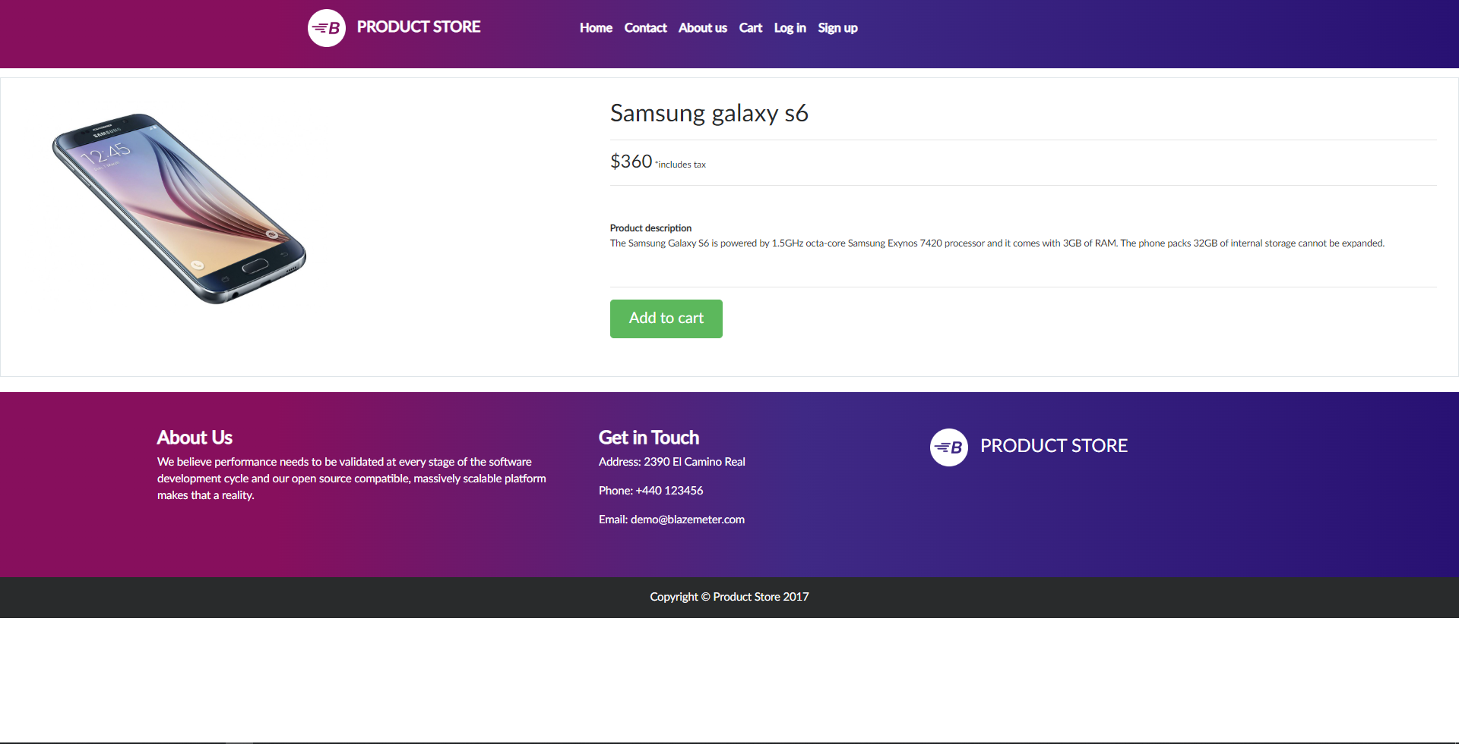

Below the footer, the application has a white and void space that can be used for more information’s and “special promotions”.

2. the application does not have accessibility points for people that need some assistance like shortcuts or configuration of contrasts